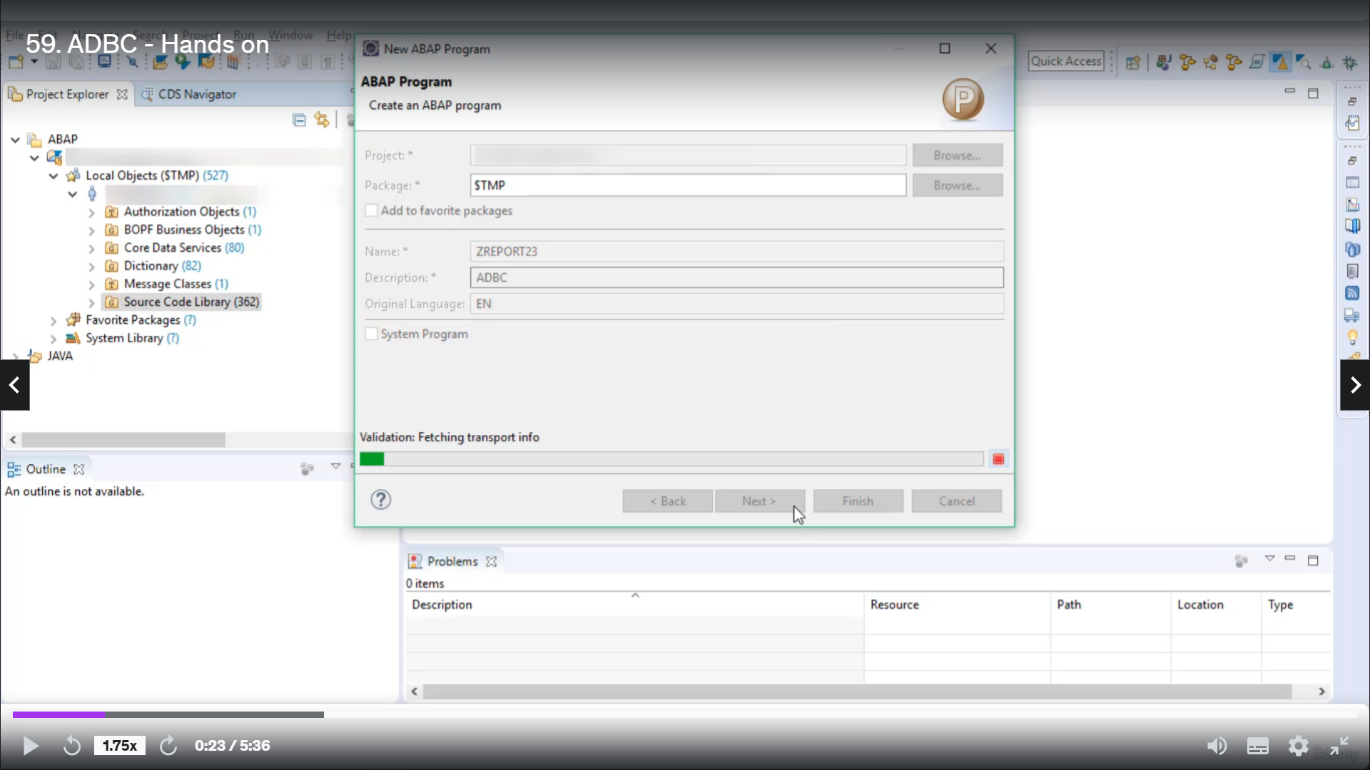

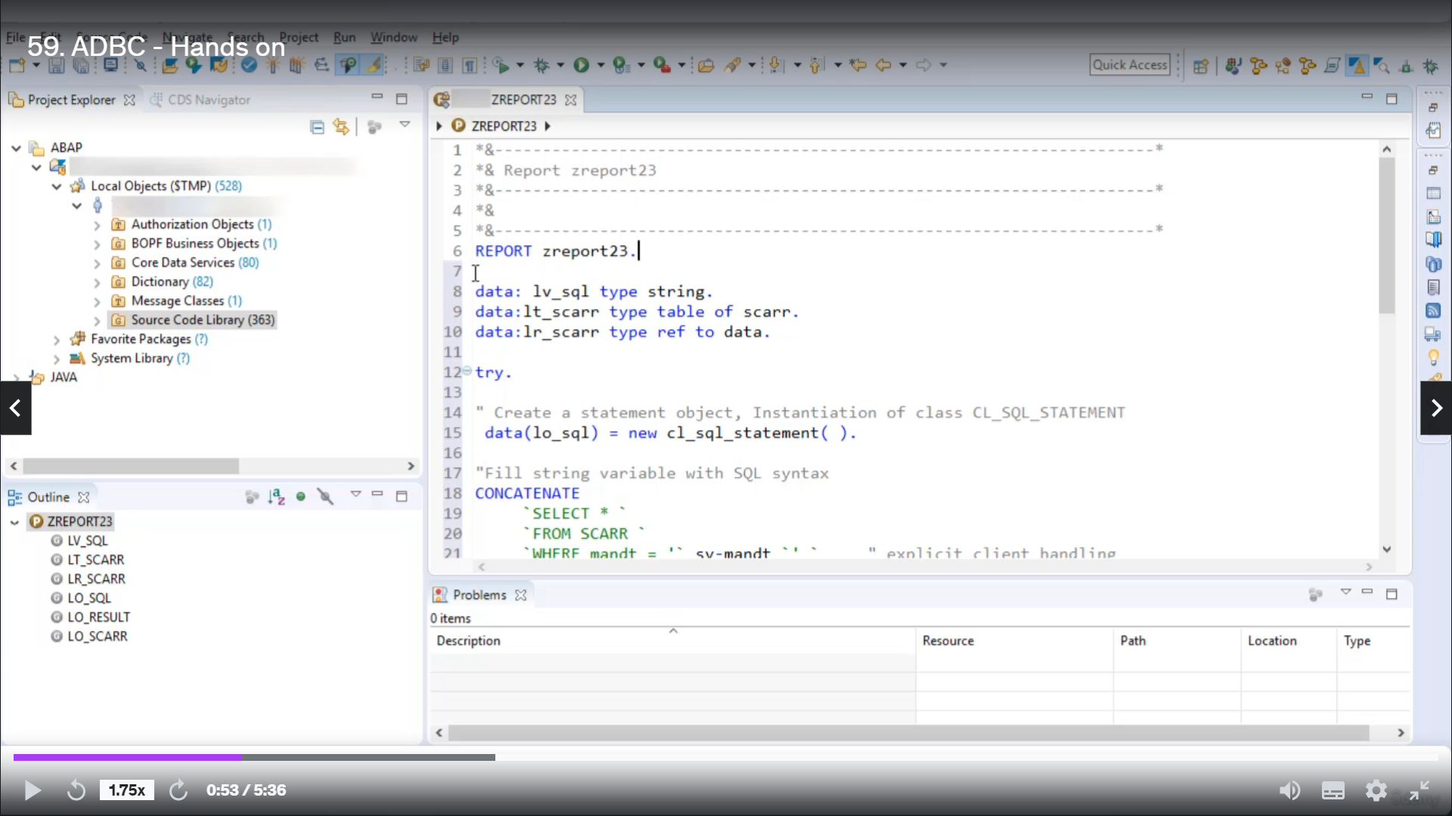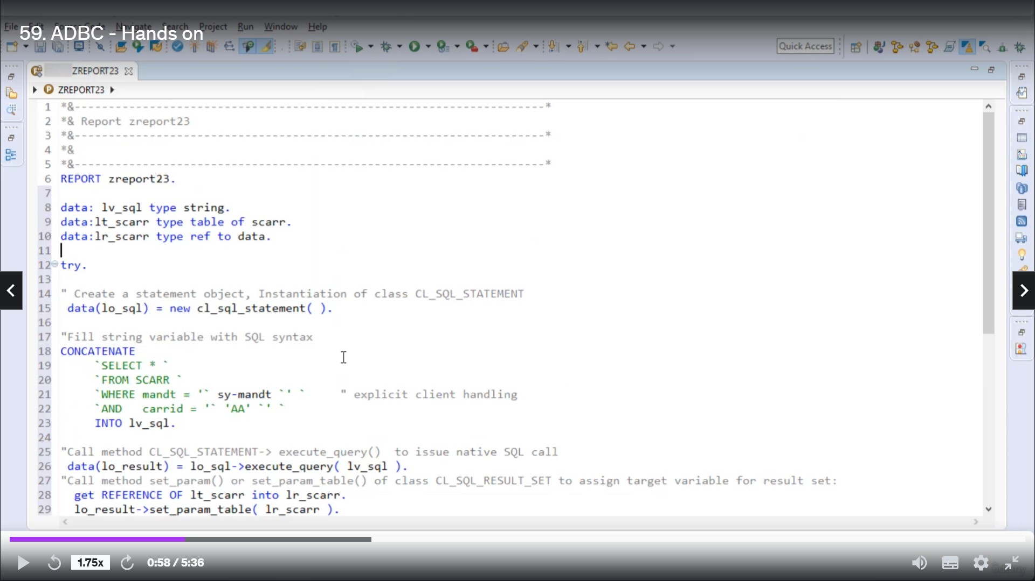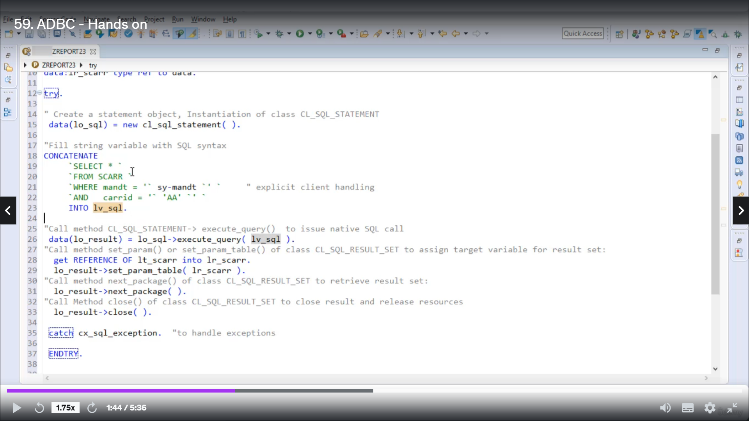

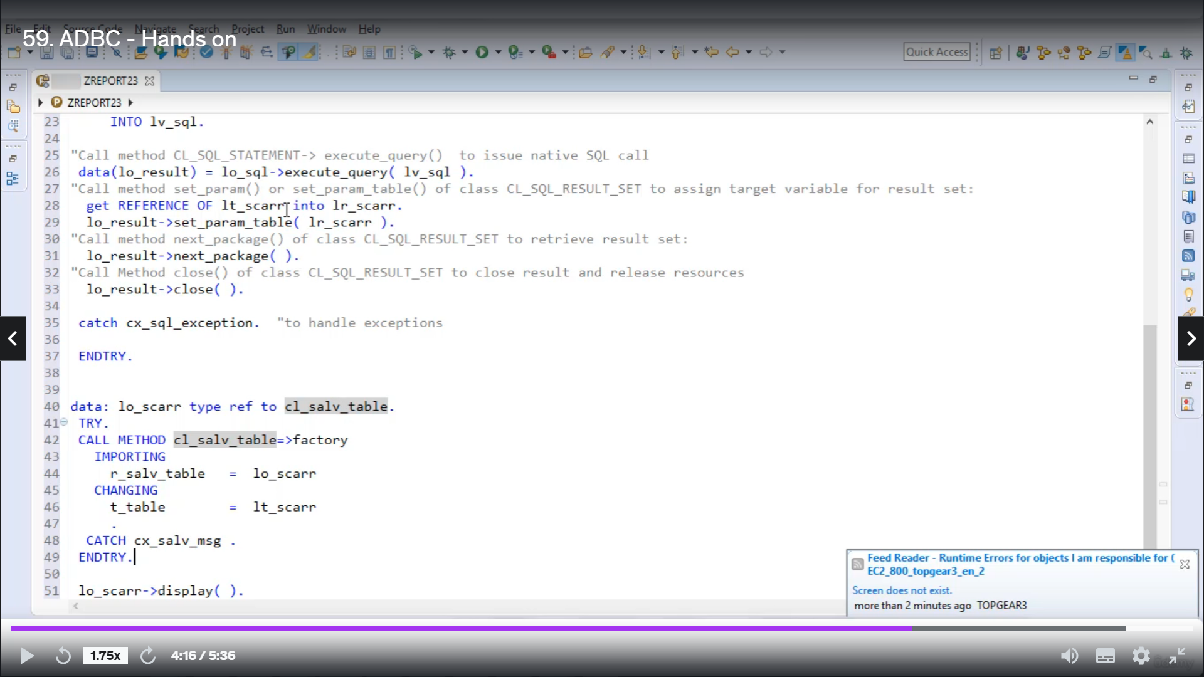

So to create a better program, right, click on Source Code Library and then select other programs.

Let's quickly give it a name as they do twenty three description as ABC.

All right, next.

Since it is very straightforward to use ABC in a report program, hence I will directly use my already

written code.

With this course, I'm also going to provide you all my written calls so you can directly use it just

by copy paste, read and see the output.

So now let's see how to use it in our program.

Step one, you have to create object of glass because it's clear statement, so I'm using your new inline

declaration syntax to create Object Eluay skill.

Then in second step, we are to fill string variable with a script syntax.

So I have already declared you one string variable and I will use concatenate this building function

in new open Eskil to concatenate all these strings into Variable and Vizquel.

So let's see what we do then you.

These are not a single cold, but relaxing single.

OK, so let's start the next segment is from Table Square, their amended request to asway amended and

Garatti goes to.

So once you concatenate these statements into a variable LBA scribble in the third step we are to call

method execute query to issue to a call and the return from the call you are to collected into local

object a result.

And the next step here, you're going to get reference of Internet cable star, which is of time, Scott,

into reference variable Ólavsøka, then using a loaded object here to give a call to meter set parameter

table.

And you have to parse reference variable Ólavsøka to this method.

Hence you are assigning target variable for ResultSet and the next day, again using object result.

We are to give a call to metter next package to retrieve ResultSet.

Once this method good executed result, you're restoring to the internal table a ID scan and in the

next day you are to call method close to close result and release results.

All these statements you have to write under dry and dry, and if there are any exceptions occur, you

are to get charged with class, see a school exhibition.

Once you have done with all the state after execution, the internal debate in this car will hold desert

then to display the content in the desert, it is God, you can use classic a silver table here to give

gold to static metal factory.

You are to pass the internal table to this metal and you are to collect the instruments of the created

object into local object.

ACOR using this local object, you can Google to me display it.

Once this statement get executed or put, will you get displayed on your screen.

OK, so let's first activate this code and then execute.

So as a result, you got this output since we want to fage all the fields from people's care, where

Gary is he?

So there is only one record matching this condition in this table.

So only one record will get displayed.

And that's it for now, I hope you understood the working of ABC and how you can use it in your program.

Thank you for watching with you.

Have a great day.